**WORLDWIDE SUICIDE PREVALENCE ANALYSIS**

***Data cleaning***

I did the following:

* Removed the gridlines
* Aligned all the data in the sheet to the center
* Color formatted the header row and boldened the text
* Changed all the column headers which had values that started with a lower case to upper case
* Changed the column headers gdp_for_year, HDI for year, and suicide_per_hundred_k_pop to GDP(Yearly), HDI(Yearly), and Suicide Rate (Per_100K_Population) respectively
* Formatted the Year column values from text to proper dates by using Find and Replace to switch its values e.g., 1985 for 12/31/1985
* Changed all the other data types to their proper data types.
* I included a serial number column so I can use it as a unique key to populate my analysis table using the index and match function.

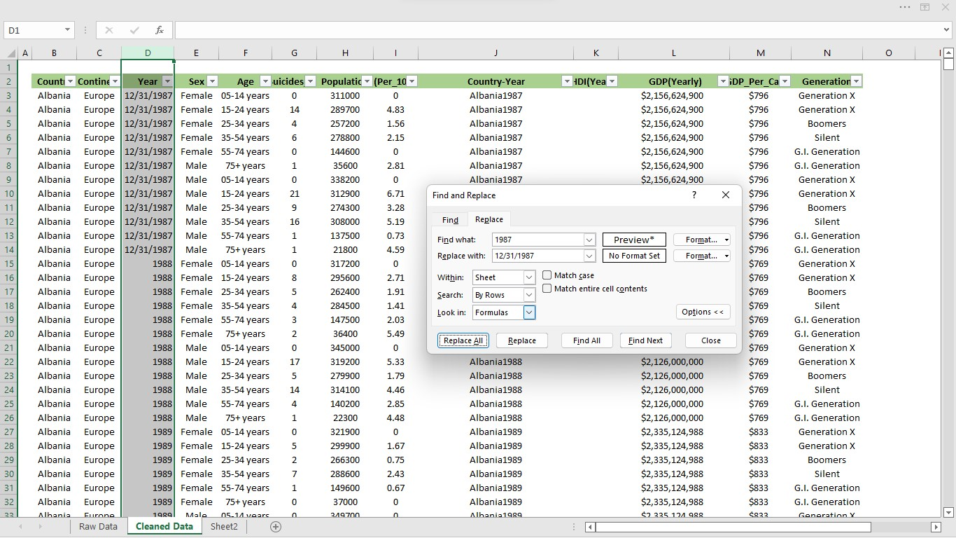

***Sheets & Tables***

I made the following sheets and tables:

* **Raw Data Sheet**: this worksheet contains all the source data without any formatting
* **Clean Data Sheet**: this worksheet contains the cleaned version of the raw data. From it I made the **Cleaned Data Table**.
* **Analysis Data Sheet**: This sheet contains data that I want to use in my analysis. I populated this sheet using index and match from the Clean Data Table. From it I would make the **Analysis Data Table**.

***Analysis***

My Analysis goals are:

* Descriptive Analysis:

|  |
| --- |
| **Descriptive Analysis** |
| Which continent or country has more suicide cases than the other |
| Which continent or country has less suicide cases than the other |
| Total No of Continents or Countries with suicide cases |
| What year did we record the highest or lowest suicide rate. |
| The spread of male vs female suicide cases |
| Total count of males and females that have committed suicide |
| Whats the age spread of suicide cases |